**Microprocessor Lab**

Laboratory Activity No. 2

**Arduino and Tinkercad Interface**

|  |
| --- |
|  |

Score

*Submitted by:*

**Mendoza, Kenji J.**

**<Schedule> / <Section>**

*Date Submitted*

**30-09-2023**

*Submitted to:*

**Engr. Maria Rizette H. Sayo**

I. Objectives

This laboratory activity aims to implement the principles and techniques of hardware programming using Arduino through:

- creating an Arduino programming and circuit diagram.

II. Method/s

- Perform a task problem given in the presentation.

- Write a code and perform an Arduino circuit diagram of a ring counter that display eight (8)LEDs starting from left.

III. Results

**TinkerCad**

**Exercise 1: Write a code that does a ring counter display for eight (8) LEDs starting from left.**

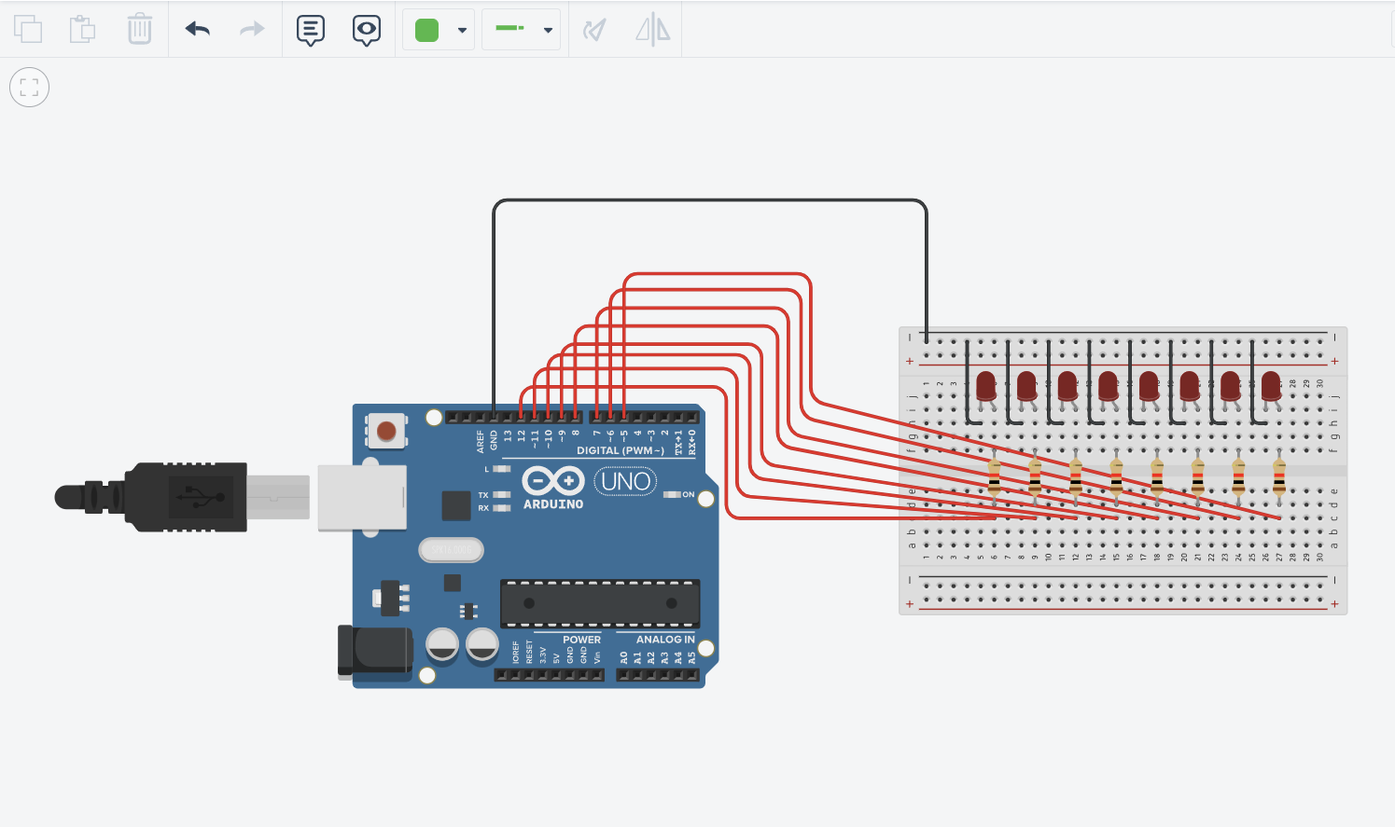

Figure No.1 Ring Counter Display Circuit Diagram

**Components Used**

1. 8 LEDs
2. Resistor
3. Breadboard

**CODE:**

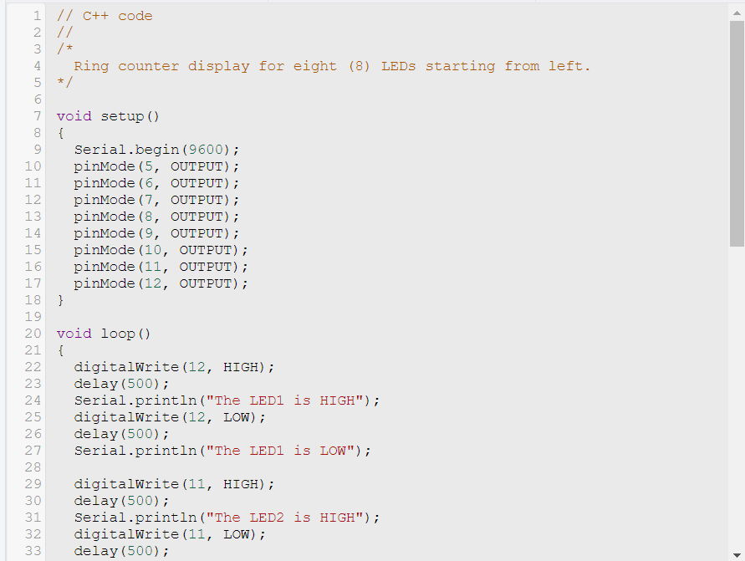

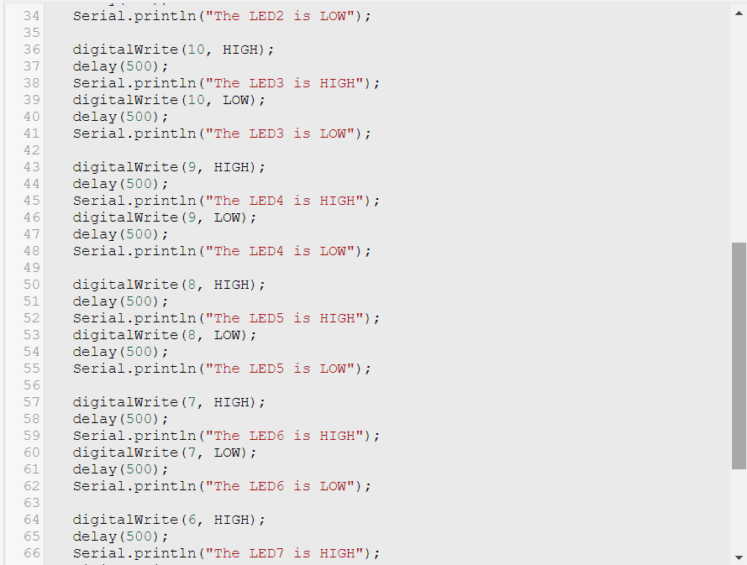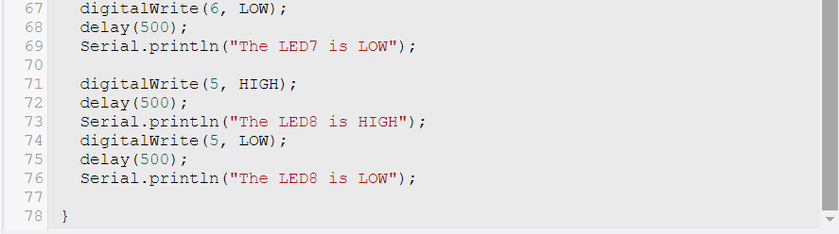

IV. Conclusion

*The conclusion expresses the summary of the whole laboratory report as perceived by the authors of the report.*

*CODE*

**References**

[1] D.J.D. Sayo. “University of the City of Manila Computer Engineering Department Honor Code,” PLM-CpE Departmental Policies, 2020.

*<This is in a separate page>*